**Project Summary**

The project goal was to help Seattle Department of Transportation (SDOT) in their process of developing a bike sharing system as they review their recent pilot program. We explored open source data sets from the bike sharing systems of Chicago, Los Angeles, and Washington, D.C. to determine characteristics of bike sharing programs in other U.S cities.

Bike sharing is a short-term bicycle rental system. A user picks up and rents a bike from a station, uses it for as long as they need, and then return it to the same or a different station. Most systems have membership options but typically allow non-members to use the bikes.

Our audience is SDOT, particularly the director of the department and financial decision makers. We identified several key factors of bikeshare systems: number of bikes in the fleet, popular routes and stations, busiest times of day, impact of weather, and usage by different demographics.

The bikeshare data comes from the respective transportation municipalities of Chicago, Los Angeles, and Washington, D.C. for April, May, and June (Quarter 2) of 2018. Processing entailed renaming column names to be congruent, converting the duration from seconds into hours and minutes. The weather data comes from Weather Underground, a website owned by IBM Business.

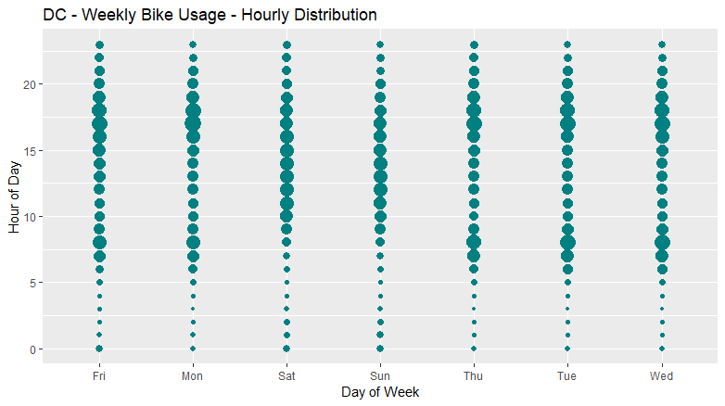

This plot displays aggregated ridership over time in Washington, D.C. over the study period. The x-axis is the day of the week and the y-axis is the time of day in hours. Each bubble represents the number of rides taken during that hour. On weekdays, ridership is highest in the rush hours. On weekends, ridership grows and then remains stable during daylight hours. We can interpret that bikes are being frequently used by the working-class during weekdays.

Based on number of rental initiations and terminations, we determined the stations visited most often are near tourist attractions and train stations. Another important analytical result is the top five most popular start and end stations in each study we studied.

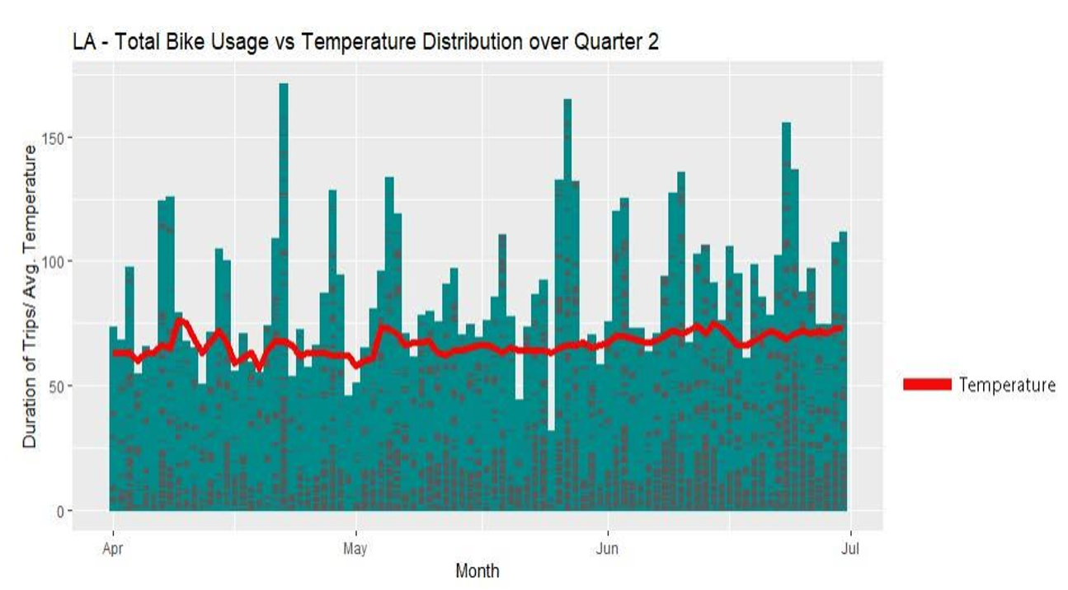

Using the weather data, we plotted a relationship between bike usage and weather and concluded that bike usage drops when weather decreases below 50 Fahrenheit. We also utilized the data to plot other multiple other relationships such as between bike usage and customer type to discover that walk-ups constitute of most round trips taken and monthly pass holders make the most frequent trips. An example is provided below:

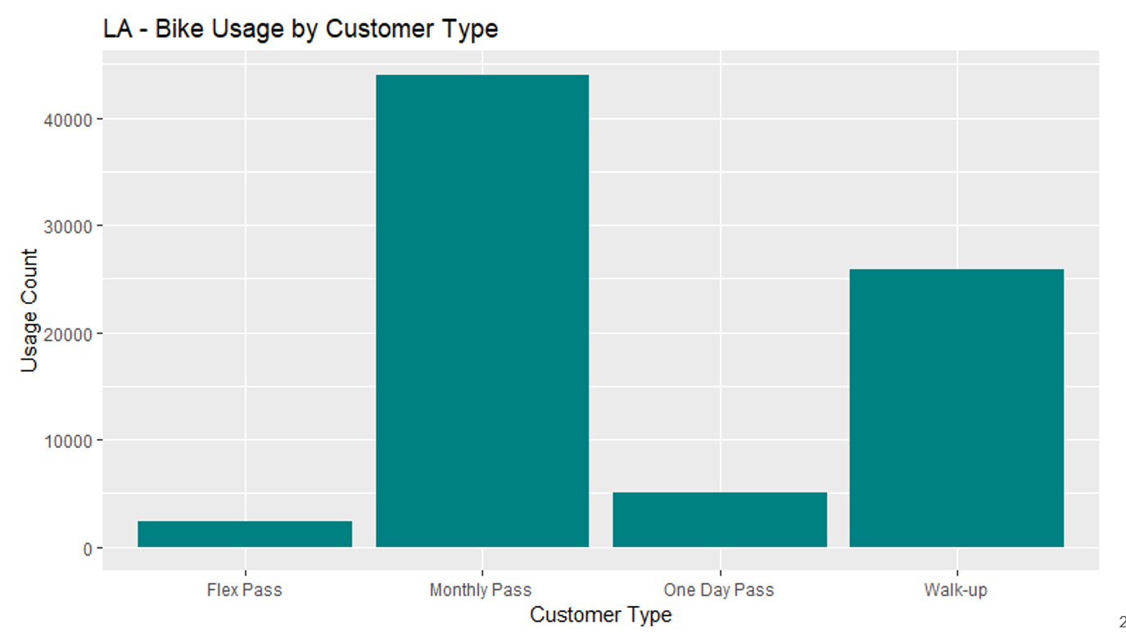

This knowledge will be important for Seattle to have enough docked bikes at major attractions and transit hubs. The docked bikes would decrease losses incurred due to lost bikes. Based on Trip Advisor ratings, we suggest places such as the Seattle Space Needle, King Street Train Station, Pioneer Square, and Chihuly Garden and Glass Museum and to offer coupon codes or rewards such as a hot coffee whenever weather is about to get chilly. SDOT should also allow for easy membership enrollment by providing lucrative incentives or credit points, as once a user becomes a member, they are more like to take trips

Word Count: 500